**SART Monthly Webinar** 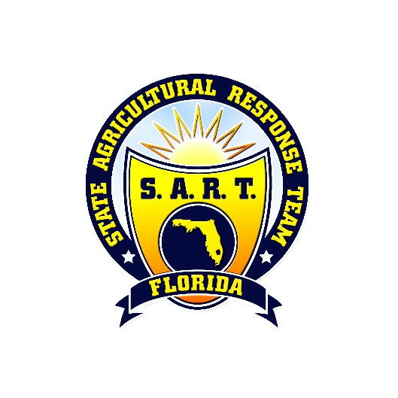

Thursday, May 18th, 2023

10:00am – 11:00am

**Please join meeting from your computer, tablet, or smartphone.**

**Microsoft Teams meeting**

**Agenda**

10:00 **Call to Order/Welcome/Review of Agenda –** Kris Abel (FDACS)

10:05  **Regular Business –** Kris Abel (FDACS)

* 2023 In-Kind Partner Contributions
* Incident Command System (ICS) Training Opportunities
* Reminder: Review SART Partner Contact List for Updates

10:20 **Budget and Upcoming Activities Update –** Emily Nolen (FDACS)

10:30 **2023 SART Workshop Update and Discussion –** Emily Nolen (FDACS)

10:50 **SART Partner Updates and Roll Call –** All

***2023 SART Planning Workshop: June 6th-8th, 2023, Daytona Beach, FL***

***Next SART Monthly Webinar: Thursday, July 27th, 2023, 10:00am – 11:00am.***